Session Notes

Day2 [9Jul]

Session Diagrams:
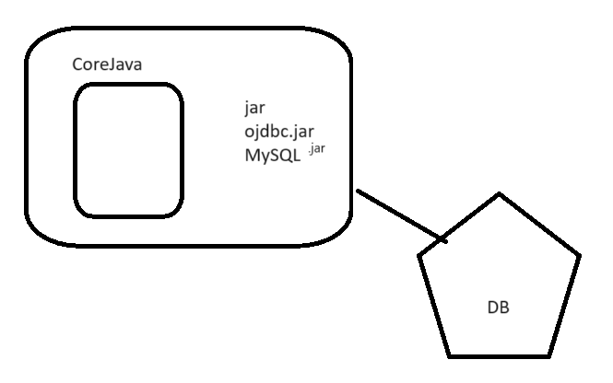
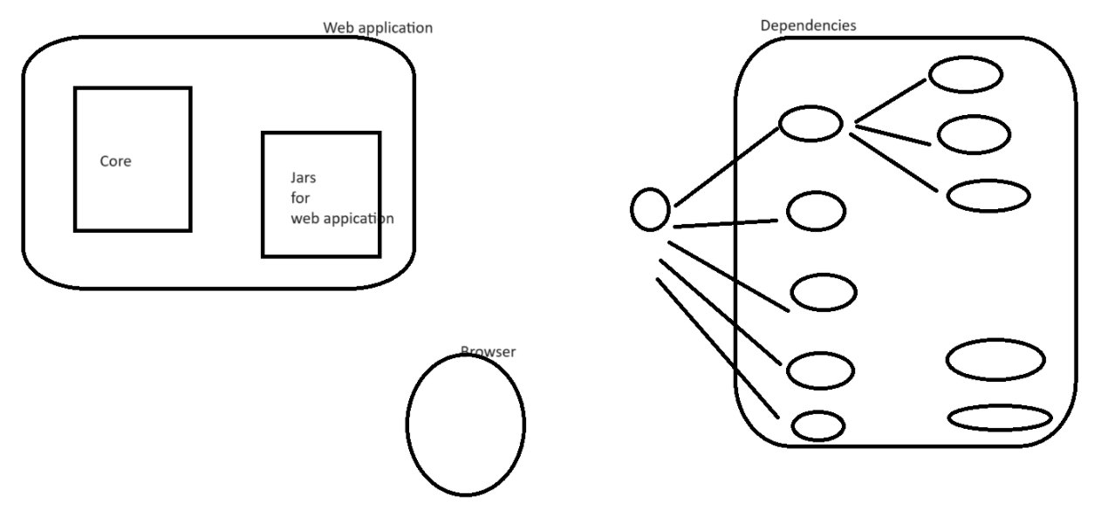

LIVE Notes
Day2: End-to-end working in IT.
Complete TOOLS & PROCESS.

Agile
JIRA

End-to-end process - SDLC

- Product Owner
- Product Backlog
- UserStory

1. Client / Business some requirement.
2. Explain to Product Owner
3. Product Owners (PO / Product) - understands the requirement from client. Write it as UserStories & puts it into JIRA.
4. PO has to explain these requiremetns to Tech Team:
Grooming Meeting / Refinement meeting /
Requirement Gathering meeting
Microsoft Teams - Chatting & meeting purpose
Outlook - emails
Setup a meeting request meetin links Microsoft Teams
PO, SM, Technical Team

WHiel writing requirements
1. Userstory:
As a <user>
I want <what>
so that <why>
2. Acceptance Criteria
Bullet points:
- Show link of forget password on login page
- when user clicks link, open a popup & ask for email
- Validate whether email existing in system
- If email invalid, show error message to user, that email doesn't existing
- If email valid, then generate reset passwork link in backend, and email to the customer.
- restpassword flow

3. UI "Mockups"

CSS/Bootstrap

UI/UX developers
Angular/React - frontend

Java dev
DB
Devops

ANy questions, you raise it with product owner
FUnctional req + Tech aspect both check on it.
Dont complicate code. Long term maintenance

70-80% clear,
dont start development, if requirement is not 70-80% clear.

DOR (Definition of Ready)

5. Ask for estimation (how much time it will take to complete requirement)
2 days / 3day

Give us estimates in the form of "Story Point"
1 2 3 5 8 13 ....

1. Time
2. Complexity
3. Risk

Without analysis, no giving estimation

6. INternal Grooming Meeting
Discuss these requirements internally.

High level, how you want to implement this?
highlevel design
- Microservice - in which service, what code to be written
- open sources
- DB design
- API design
- Performance
- Security
- Existing reusable logic

Giving "Story Point"
1 2 3 5 8 13 ....

"6": 5 + 1 + 0
Closest 5

Story Point Estimate : 5

"Man Days"
1. Time
UI: 2days + 0.5days unitesting? 2.5days FE
Server? 3days + 1unittesting: 4days
Tester? 1.5 testcases + 2 testing: 3.5 days

10days / 2 = "5"

2. Complexity - 1
0, 0.5, 1, 1.5, 2
3. Risk - 0
0, 0.5, 1, 1.5, 2

7. For all requiremetns, you would get 100% clarity of how to implement & storypoint

8. IN 2 weeks, how much work you can finish.
Sprint duration: 2 weeks.

Sprint Planning Meeting (Day1 of the sprint)
Sprint1:
Start: 8Jul
End: 19Jul

How much work we can finish?
Who is going to work on what features
UI - Java - test
2 ui - 3 java - 2 qa

Planned Leaves
Again ask for clarification of requirement
Mon-fri, 8/9 working

Subtasks
UI task, server task, qa testcase, qa execution

Task Breakout

About to implement feature.

Day1 of sprint:
Team is clear, what features needs to be developed in upcoming 2 weeks.
Who is going to work, on what features is clear.
ANyone on leave is clear.
Highlevel implementation approach is also clear.

Refect the list of features for current sprint, in Jira.
"Start Sprint"

ON daily basic, any progress happening in application development, should be reflected into Jira.
Update Jira status, to refelect the current state of work.

TODO | INPROGRESS | QA | DONE

9. About to work!!!!

Spring Boot & Microservice Project.

Core Java + JDBC + Basic of Web(Servlet/server)
-----------------------------

Core Java

Sprint Boot -
WebApplication (Something which can be accessed across Internet)

Browser you can access it.

https://roadmap.sh/java

Multiple frameworks for

Core java + Web framework = Web application

=====
Core Java
+
"Spring Boot"
=====

Where to find all these jar??

5-10 jars

Business
Software
Coding & deliver

1. Core Java + SPring Jars = Web application
2. Searching these jars are not possible manually..
Build Tool: "Maven"
3. Customer want software as quickly as possible.
Without even knowing spring, you can build your first application.

https://start.spring.io/
And fill maven specific details

Group: which company developed this code?
website: google.com
Group: com.google

Artifact: End output of your project.

A.java
javac
java

For web application - BuildTool
1. Develop
2. Compile
3. Execute (Server: Tomcat)
jar

war

Generate:
Create your 1st Spring Boot application with web dependency.

1. Got the project from start.spring.io
2. COding on this project
IDE: Eclipse,...., Spring STS
https://spring.io/tools
3. Get the project (which we generated from start.spring.io) & include in your IDE.
Import => Existing Maven Project
All Maven configurations: pom.xml

Maven:
Build tool
Dependencies for us
pom.xml
group, artifact

maven commands
-----
if you install maven manually in laptop
mvn clean
mvn install - gets the newly added dependencies in your projet
mvn package - builds archive file

PATH .. exe, maven/java

com

IDE,
java default installed
Maven default installed in IDE.

Version

run using IDE way:

clean
install - gets the newly added dependencies in your projet
package - builds archive file

javac A.java
java A

a.jar

mvn package
"Executable Jar files"
java -jar a.jar

Core Java into a SPring Boot.

Web application

You can build a standalone application using spring/springboot

Web application - additional dependency

